

# 

COMPLAINT : 1

DATE: 13/Mar/2021

The Manager,

BANK AL-HABIB

233,KPK ZONE

Subject: Quotation of Repair and Maintenance. FOR APPROVAL

Number of AC: 1

|  |  |  |  |  |
| --- | --- | --- | --- | --- |
| Sr. | Job Description | Qty | Rate | Amount |
|  | 3 | 1 | 3.0 | 3.0 |
|  | 3 | 1 | 3.0 | 3.0 |
|  | 3 | 1 | 3.0 | 3.0 |
|  | Total |  |  | 9.0 |
|  | Tax 16% |  |  | 1.44 |
|  | Conveynce Charges | 33 | 0 | 0 |
|  | Total |  |  | 10.44 |

**Yours truly,**

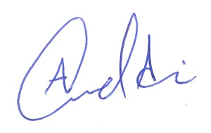 **ECO ENTERPRISES**